**Hafsah Zulqarnain**

**Rijja Masood**

**21l-5315**

**21l-7590**

**BCS-3N**

**Project #02**

**01-01-23**

**REPORT**

**Research and Feasibility study of Resale Business**

**SECONADRY RESEARCH ON RESALE INDUTRY AND FEASIBILITY STUDY**

**Prepared for**

**Prof. Salmaan Rahman**

**FAST NUCES Lahore**

**Prepared by**

**Hafsah Zulqarnain**

**Rijja Masood**

**Table of Contents**

**Introduction** ------------------------------------------------------------------------------------------------------ 04

**Section -I** ------------------------------------------------------------------------------------------------------------07

Secondary Research---------------------------------------------------------------------------------------07

Fashion-------------------------------------------------------------------------------------------------------07

Fast Fashion-------------------------------------------------------------------------------------------------07

Second Hand Clothing------------------------------------------------------------------------------------09

Vintage Clothing-------------------------------------------------------------------------------------------10

History of Vintage Clothing-----------------------------------------------------------------------------11

The rise of Vintage Fashion And Vintage consumer ---------------------------------------------12

Places that sell vintage clothing-----------------------------------------------------------------------13

The rise of second hand clothing market-----------------------------------------------------------14

Most popular vintage items for men and women------------------------------------------------16

Motives Behind the choice of Vintage over Fast Fashion---------------------------------------17

SWOT analysis --------------------------------------------------------------------------------------------19

Online Shopping------------------------------------------------------------------------------------------23

Influence on Customers behavior -------------------------------------------------------------------25

Synthesis of Vintage store and online shopping -------------------------------------------------25

**Section -II** ---------------------------------------------------------------------------------------------------------27

Feasibility Analysis --------------------------------------------------------------------------------------27

Product (good or service) Analysis ------------------------------------------------------------------27

Product Desirability----------------------------------------------------------------------------28

Product Demand--------------------------------------------------------------------------------31

Industry and Target Market Analysis----------------------------------------------------------------32

Organizational Feasibility------------------------------------------------------------------------------36

Financial Feasibility -------------------------------------------------------------------------------------39

Pros and Cons of vintage clothing business ------------------------------------------------------40

**Conclusion**-------------------------------------------------------------------------------------------------------45

**References**-------------------------------------------------------------------------------------------------------46

**INTRODUCTION**

The following are the two ideas being thought about :

* **Idea # 01** (Hafsah’s idea) :

This business idea is for an ***online vintage store*** that sells clothing items. This would be a platform restricted to only purchasing products. All of the available products will be categorized, allowing customers to quickly select the items they want with only a click. Customers would be able to find unique and one-of-a-kind clothes at a convenient site. This online store would be called V for Vintage, and it would only sell clothes that were made in the past but are no longer made. It would be an online application that caters to the wants and needs of twenty-first century consumers.

* **Idea # 02** (Rijja’s idea) :

This business idea is about developing a “Decentralized E-commerce Marketplace”. It will allow different sellers to sell products using this platform and will allow for peer-to- peer transactions that are not governed by a central authority and processes transactions without any centralized control. The most important functionality like executing trades and releasing funds will be controlled by a smart contract or program instead of a person so it will be more reliable. Decentralization of Blockchain will help us building up a marketplace that protects the user’s personal information. As we will be providing a payment method alternative and a way to secure personal information for our customers , we will ensure trust in transactions because decentralization makes it harder to tamper with.

The idea selected for our project is the #01. No doubt idea #02 is revolutionary but it has some limitations. Let’s have a look :

***Very challenging implementation***

Designing and developing a Decentralized marketplace is a truly challenging task. Strict yet unclear regulatory obligations and complicated technological frameworks introduce possible drawbacks in decentralized finance projects.

***Lack of Regulatory Compliance***

As we know a decentralized transactions system is a decentralized entity that is not controlled by any central bank, authority, or third party. It operates independently that imposes certain regulatory requirements. Due to financial crimes such as money laundering and terrorist financing, traditional banking systems are highly regulated. Whereas, in a centralized financial system, transaction processes are keenly monitored and any fraudulent transaction immediately blocks the sender and receiver accounts. There is no such protection in the decentralized transactions system.

***Scalability & Performance***

Decentralized Apps inherit two major benefits: transparency and security. However, one of its major drawbacks is inefficient performance. When compared to centralized financial systems, decentralized transactions system turn out to have slow transaction speeds as well as scalability issues. As a result, processes take too much time and ultimately affect the overall performance of the network.

Moreover the idea #01 is very unique and it is the right time and circumstances for this idea because how it fits in the trends and gaps as follows :

**Trends:**

Vintage clothes are trendy for a number of reasons. The popularity of online vintage stores is on the rise as people are becoming more interested in sustainable and unique fashion.

***Social Trend***

First, from a social standpoint, vintage items often have a story or history behind them that can be appealing to consumers.

***Environmental trend***

By shopping secondhand we can help reduce our environmental impact by reusing goods instead of buying new ones (which require energy and resources to produce).Using old products can give you a sense of satisfaction that comes from knowing you are doing your part to reduce waste and help the planet.

***Demographic Trend***

With constantly changing demographics not only aging individuals but young people are also showing interest in vintage items and those who enjoy having more refined style tend to collect vintage stuff.

***Economic Trend***

From an economic perspective, vintage products may be seen as more affordable than new items , especially if they are of high quality. In an economic downturn, people may be willing to switch to cheaper options for goods and services. There are many benefits to buying used products instead of new ones. Used products are often just as good as new ones, but they cost less. In economically weak countries, people may be willing to switch to cheaper options for goods and services, but they may not necessarily be willing to accept lower quality.

***Technological trend***

Advances in technology will make it easier for consumers to find and purchase vintage items online or through other channels.

All of these factors combine to make vintage products an appealing option for many consumers today.

**Gaps:**

There are a few reasons why no one in Pakistan is selling good condition and reasonably priced vintage products.

* Most sellers do not have the knowledge or expertise to properly evaluate the condition of their products. This lack of knowledge often leads to overpricing, which further discourages potential buyers. Many Pakistani sellers simply do not have access to good quality vintage products. With so few options available, it's no wonder that prices remain high and selection remains low.
* There is a gap in the Pakistani market for selling good condition and reasonably priced vintage products. This is due to the fact that there are not many stores that sell vintage products and the ones that do are overpriced. This leaves customers with few options when it comes to finding affordable vintage items.
* One way to fill this gap would be to start an online store that specializes in selling good condition, reasonably priced vintage products. This would allow customers from all over Pakistan to have access to affordable vintage items without having to travel long distances or pay high prices.

**Solution:**

* It would allow us to shop for vintage items from the comfort of our own homes, instead of going to flea markets searching around for good products endlessly.
* It would give us access to a selection of unique clothing items so everyone doesn’t ends up having the same mass produced products.

**SECTION-I**

**Secondary Research**

**FASHION**

***Fashion*** is best defined simply as the style or styles of clothing and accessories worn at any given time by groups of people. There may appear to be differences between the expensive designer fashions shown on the runways of Paris or New York and the mass-produced sportswear and street styles sold in malls and markets around the world.

**FASHION INDUSTRY**

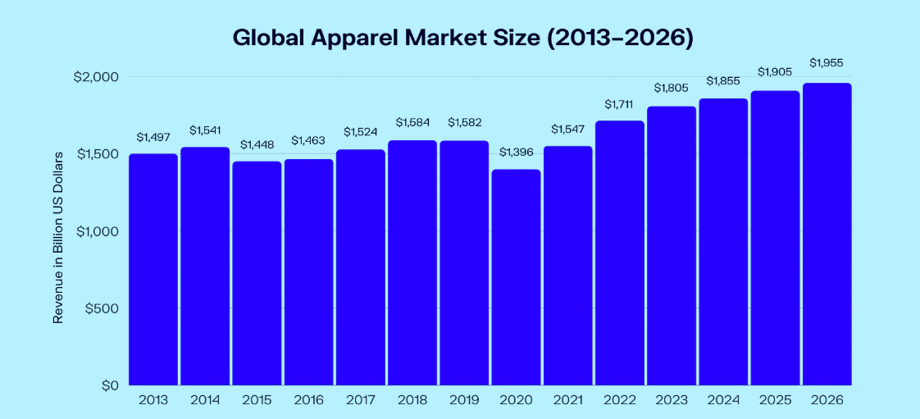***Fashion industry***, multibillion-dollar global enterprise devoted to the business of making and selling clothes. Some observers distinguish between the fashion industry (which makes “high fashion”) and the apparel industry (which makes ordinary clothes or “mass fashion”), but by the 1970s the boundaries between them had blurred.

**FAST FASHION**

***Fast fashion*** can be defined as cheap, trendy clothing that samples ideas from the catwalk or celebrity culture and turns them into garments in high street stores at breakneck speed to meet consumer demand. The idea is to get the *newest styles* on the market as fast as possible, so shoppers can snap them up while they are still at the height of their popularity and then, sadly, *discard* them after a few wears. It plays into the idea that outfit repeating is a fashion faux pas and that if you want to stay relevant, you have to sport the latest looks as they happen. It forms a key part of the toxic system of *overproduction* and consumption that has made fashion one of the world’s largest polluters.

**How did fast fashion happen?**

To understand how fast fashion came to be, we need to rewind a bit. Before the 1800s, fashion was slow. You had to source your own materials like wool or leather, prepare them, weave them, and then make the clothes.

The ***Industrial Revolution*** introduced new technology—like the sewing machine. Clothes became easier, quicker, and cheaper to make. Dressmaking shops emerged to cater to the middle classes.

Many of these dressmaking shops used teams of garment workers or home workers. Around this time, sweatshops emerged, along with some familiar safety issues.

By the *1960s* and *70s*, young people were creating new trends, and clothing became a form of personal expression, but there was still a distinction between high fashion and high street.

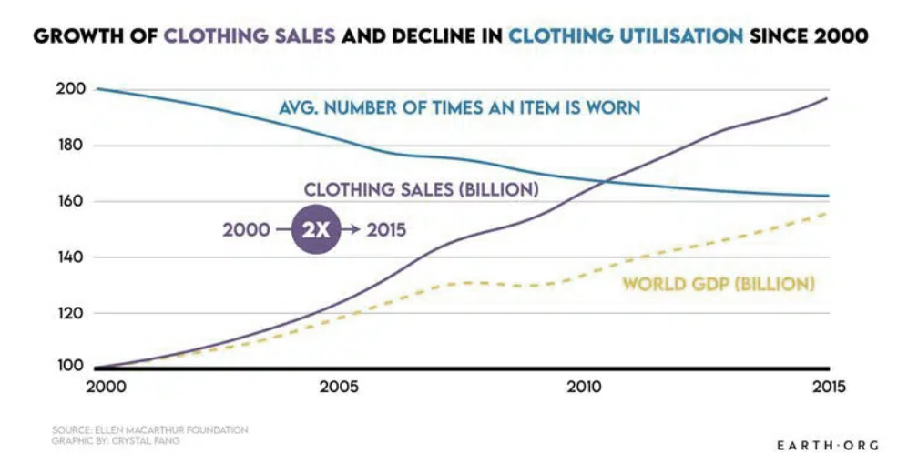In the late 1990s and 2000s, low-cost fashion reached a peak. Online shopping took off, and fast-fashion retailers like *H&M, Zara*, and *Topshop* took over the high street. These brands took the looks and design elements from the top fashion houses and reproduced them quickly and cheaply. With everyone now able to shop for on-trend clothes whenever they wanted, it’s easy to understand how the phenomenon caught on.

**Why is fast fashion bad?**

**Polluting our planet:** Fast fashion’s impact on the planet is immense. The pressure to reduce costs and speed up production time means environmental corners are more likely to be cut. Fast fashion’s negative impact includes its use of cheap, toxic textile dyes—making the fashion industry the one of the largest polluters of clean water globally, right up there with agriculture. That’s why ***Greenpeace*** has been pressuring brands to remove dangerous chemicals from their supply chains through its detoxing fashion campaigns through the years.

Cheap textiles also increase fast fashion’s impact. Polyester is one of the most popular fabrics. It is derived from fossil fuels, contributes to global warming, and can shed microfibres that add to the increasing levels of plastic in our oceans when washed. But even “natural” fabrics can be a problem at the scale fast fashion demands. Conventional cotton requires enormous quantities of water and pesticides in developing countries. This results in drought risks and creates extreme stress on water basins and competition for resources between companies and local communities.

The constant speed and demand mean increased stress on other environmental areas such as land clearing, biodiversity, and soil quality. The processing of leather also impacts the environment, with 300kg of chemicals added to every 900kg of animal hides tanned.

The speed at which garments are produced also means that more and more clothes are disposed of by consumers, creating massive textile waste. According to some statistics, in Australia alone, more than 500 million kilos of unwanted clothing ends up in landfill every year.

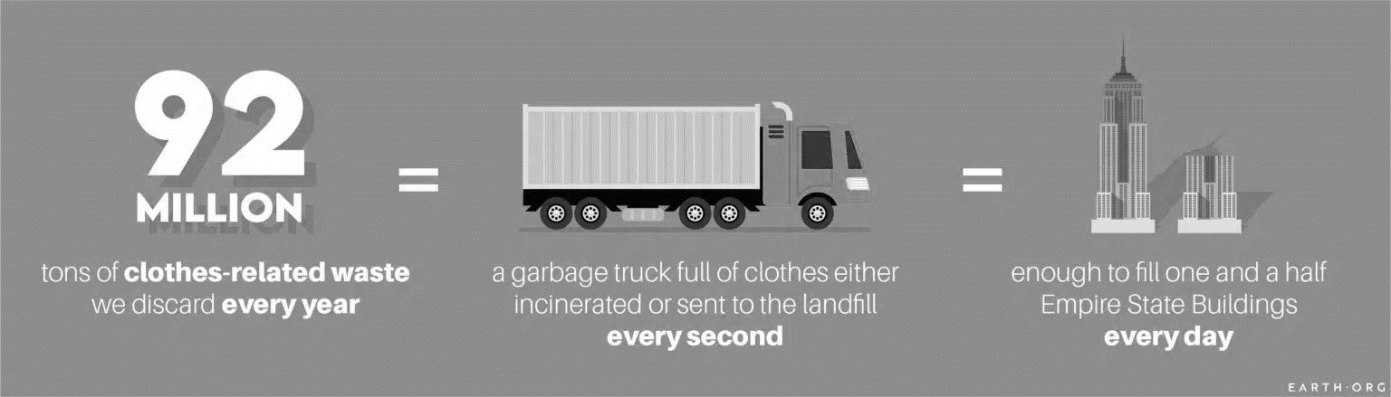

**Statistics about Fast Fashion Waste**

* 92 Million Tonnes of Textiles Waste is Produced Every Year
* The Apparel Industry’s Global Emissions Will Increase by 50% by 2030
* The Average US Consumer Throws Away 81.5lbs of Clothes Every Year
* The Number of Times a Garment is Worn Has Declined by Around 36% In 15 Years
* The Fashion Industry is Responsible for 20% of Global Waste Water
* It Takes 20,000 Litres of Water to Produce One Kilogram of Cotton
* $500 billion is Lost Each Year Because of Under-wearing and Failure to Recycle Clothes
* Nearly 10% of Microplastics Dispersed in the Ocean Each Year Come From Textiles
* 2.6 Million Tonnes of Returned Clothes Ended Up in Landfills in 2020 in the US Alone
* Fast Fashion Brands Are Producing Twice the Amount of Clothes Today Than in 2000

However, some solutions exists that are we not utilizing properly.

**Second-hand Clothing:**

*Second-hand clothing* refers to clothing that has been previously owned. Whether it was bought last year or five years ago, it doesn’t matter how old the item is or how many people have owned it beforehand. If it isn’t new, it’s classed as second-hand as this is the broad category term for pre-loved clothing.

Typically, second-hand items are more affordable than buying brand new, but it can depend entirely on the retail value and the quality. For example, second-hand designer handbags that have been used once or twice and are still in fantastic condition can still cost hundreds (or even thousands in some cases) of pounds. While it will be slightly less expensive than brand new, there won’t be a huge difference.

**Vintage Clothing**:

Vintage clothing refers to items that were manufactured in a different era with the most recent being the 1990s. As much as the younger generation may say, the early 2000s are not classed as vintage just yet. Vintage clothing can date back as far as 75 years, anything that’s 100 years or older will then be labelled as ‘antique clothing’. From 1970s disco to 1950s swing, each era has its own distinct style which is why vintage clothing is so popular.

This type of clothing often has a *premium price tag* that reflects the age, the condition, the brand and the rarity of the piece. You can almost guarantee that a Chanel handbag from 50 years ago will cost more than a new one as it’ll be seen as an investment or collector’s piece.

**Similarities between second-hand and vintage:**

Generally, vintage and second-hand means buying clothes that have been owned and worn by someone else already, but that’s where the similarities end.

**Benefits:**

There are a number of reasons why buying vintage or second-hand clothing is better than buying something new. It’s much more sustainable as instead of simply throwing items away to end up in landfill, you are giving it a new life and a chance to be worn and loved again. Those looking to build a sustainable wardrobe will focus on slow fashion rather than fast fashion which will do wonders for the environment. You may also find that these items are of higher quality as vintage clothing was made to last.

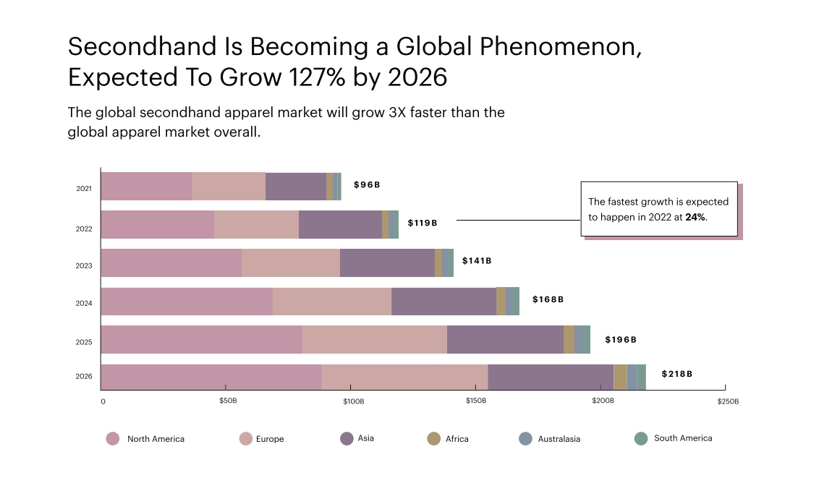

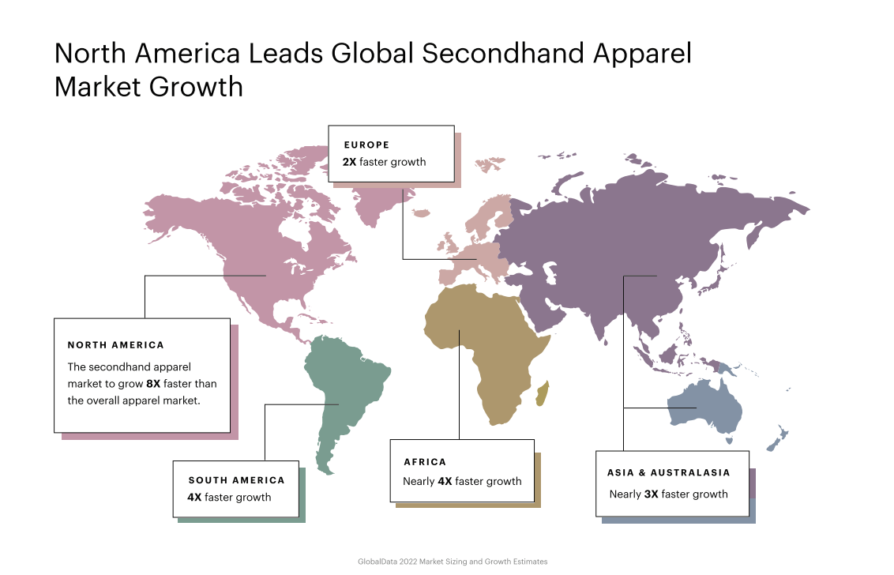**History of Vintage Clothing**

The study conducted by Culture Unbound is to specifically account for how the vintage clothing trend emerges as a *subset* of the secondhand clothing market and how the American press made sense of this sartorial practice.

* **1950’s Secondhand as Charity:** When factory-made clothing became widely available, wearing used clothing became associated with poverty; those who wore it were regarded with pity as charity recipients (Crane 2000). Apparel that looked dated in comparison to current fashions marked one as being of low social status. This association of used clothing with poverty and charity is how secondhand clothes are generally regarded from the 1890s through the 1950s

Interestingly, in 1957, the use of the phrase “vintage clothes” first appeared *in* ***The Chicago Tribune.***

* **1960’s From Resale Shops to New Youth Style:** In the 1960s, newspapers and periodicals continued associating used clothing with charity, although some reveal the meaning of secondhand clothing is changing. A 1963 article, “Resale shops are a source of good buys” in the New York Times’s “Shop Talk” section associates resale shops with luxury bargain hunting.

In 1965, Harriet Love opened her well-known vintage clothing shop in New York. In her 1982 guidebook, Love (1982: 1) characterized the mid-1960s vintage fashion scene:

“*When I began this business in 1965, the only thing that could be said*

*About vintage clothing was that it was old and used and that you had*

*to be a little weird or theatrical to buy it, let alone wear it on days*

*other than Halloween. Today every fashionconscious woman and man*

*has probably bought at least one old piece and worn it as evening or*

*everyday clothing*.”

In 1966, the Times publishes “*Thrift Shops: a Small Boom in Big Bargains*.”

* **1970’s The Mainstreaming of Vintage Dressing:**

1. *Early 1970s – Rising Popularity*

New York Times fashion editor Patricia Peterson’s 1967 characterization of the popularity of old-clothing styles as “*the beginning of a new fashion era*” was highly prescient.

1. *1970s: Peak Vintage?*

As the vintage trend builds, in 1975, Caterine Milinaire and Carol Troy publish Cheap Chic, perhaps the first consumer guidebook to thrift store shopping and vintage style. It featured individuals with unique sartorial sense who incorporate thrifted garments into their looks.

1. *Late 1970s: The Vintage Trend Reaches the Fashion Press*

1970s fears over peak demand and dwindling supply occur ten years after the New York Times first announced in 1967 that vintage dressing is a year-old trend emanating from London. Remarkably, it is at this point that fashion magazines introduced vintage to their audiences. The February 1978 issue of Seventeen was first, featuring a photo spread titled “*California Girl: Her Fashion Style: Dressing in Antique Clothes*” (Aldridge 1978). The article features a modeling contest winner dressed in various antique petticoats-worn-as-dresses, and menswear inspired by the Woody Allen film Annie Hall (released in 1977, featuring Diane Keaton costumed in vintage menswear). Seventeen included tips for buying, caring for and altering antique garments. Vogue magazine – headquartered in New York City where the vintage trend was first publicized to American audiences in 1967 – finally announces a “Boom in Vintage Clothes” in April 1979.

* **1980’s The Establishment and Diffusion of Vintage Style:**

Critics like Fraser and Hollander aside, the popularity of vintage grew in the 1980s. In December 1980, Money Magazine reports U.S. sales of secondhand clothing were up 100 percent. The New York Times shifted to mundane reporting on vintage which suggested that readers already knew what vintage was and merely needed to know where to find it and which decades’ styles were currently fashionable. Mundane reporting consisted of numerous mentions of vintage clothing being sold at flea markets, antique shows and shops, publicizing events where it was worn, and celebrities wearing vintage.

We are all aware that, more often than not, when a trend or practice originates in the United States, it spreads to other countries, and Pakistan is no different. The practice of purchasing and owning vintage clothing has been popular for more than six or seven decades, and today it is practiced not only by those who lack financial resources but also by those who want to own unique products and lessen their carbon imprint. There is hope that purchasing vintage or used clothing will catch hold in Pakistan in the coming years.

**The Rise of Vintage Fashion and the Vintage Consumer**

1. **Style, quality, and individuality**

Palmer and Clark (2005: 197) suggest that the increase in popularity for vintage fashion is an alternative response to the trend for fast fashion, which is produced in mass and leads to many people wearing the same items of clothing. Vintage consumers are trying to escape from this trend and create individual identities for themselves by wearing something unique that is often one of a kind (DeLong et al. 2005: 26). Vintage retailers support this view, Little Red Vintage interviewee states that vintage fashion is about “originality, authenticity and quality”.

1. **Eco-sustainability**

Vintage fashion can be viewed as a part of consumer interest in ethical clothing as it is considered as a form of recycling and reusing fashion. In today’s throwaway society UK consumers alone generate “2.35 million tonnes” of waste clothing in landfills every year (Fletcher 2008: 98). Arnold (2009: 64) suggests that increased media coverage on environmental issues has influenced consumers to make more conscientious purchasing decisions.

1. **Celebrities**

Celebrities also help to improve the image of vintage fashion. In the past, wearing previously worn garments was frowned upon by the fashion community and the secondhand culture was seen as something that only people with lower incomes would buy into as a form of necessity rather than desire. As Garbo Antiques interviewee states, “second-hand clothing used to be for the poor but thanks to supermodels it is now the ‘in-thing.’”

1. **Internet**

The Internet has dramatically increased the awareness and popularity of vintage fashion making it accessible to a wide audience. There is a wealth of information on the background of vintage fashions with forums dedicated to the topic that can be used to aide consumers with their purchases. There is also an influx of craft forums demonstrating the popularity of people producing handmade goods, a pastime of postwar times.

**Places that sell vintage clothing:**

* **Flea Markets:** A flea market (or swap meet) is a type of street market that provides space for vendors to sell previously-owned (second-hand) goods. This type of market is often seasonal. However, in recent years there has been the development of 'formal' and 'casual' markets which divides a fixed-style market (formal) with long-term leases and a seasonal-style market with short-term leases. Consistently, there tends to be an emphasis on sustainable consumption whereby items such as used goods, collectibles, antiques and ***vintage clothing*** can be purchased.
* **Thrift Store:** Thrift shops, or charity shops, peddle old clothing for ridiculously low prices. Their stock can offer more variety than a vintage shop, as it's based on donations, not curation. The good news: prices remain low, and the store will still make a profit, part of which many thrift shops, such as the Salvation Army or Goodwill, will donate (hence "charity" shop). The not-as-good news: more items can mean less organization. So if you plan to go thrift shopping, prepare to spend some time going through racks on racks and mounds of clothes.
* **Vintage shops:** Vintage shops offer rare, specially curated items. Sometimes those items are by well-known brands, some high-end (Gucci, Vivienne Westwood, Oscar de la Renta), some less so (Tommy Hilfiger and Levi's). From a business perspective, brands are particularly crucial to a vintage shop's' stock.

**The Rise of the Secondhand Clothing Market:**

The vintage fashion market is currently going towards a favorable period of rapid growth, acquiring more and more importance during the years, especially when considering young generations. Such climate can find in its roots in many different reasons, that can vary in their nature accordingly to the type of customer we’re considering. The increase in young generations’ awareness towards social and environmental changes has given birth to a general feeling of resentment against the fast fashion industry and its unsustainable practices. Fashion mass-production has led to a common loss of individuality, resulting in a demand for more unique and personal items. Today’s circumstances and contexts have paved the way for the rise of a type of items which allow buyers to explore their individuality and to act against the multiple disruptive changes that many economies are bringing to earth. Vintage wear, thanks to its unique garment characteristics and its sustainable nature, represents the perfect answer to the needs of young generations. Its fit to our modern time fashion claims has been clearly manifested in a rise of the general interest towards vintage fashion and sales, leading to a second-hand clothing market growth that had never been witnessed before. Current empirical researches have shown how the vintage fashion market is gradually stealing fast fashion’s spotlight.

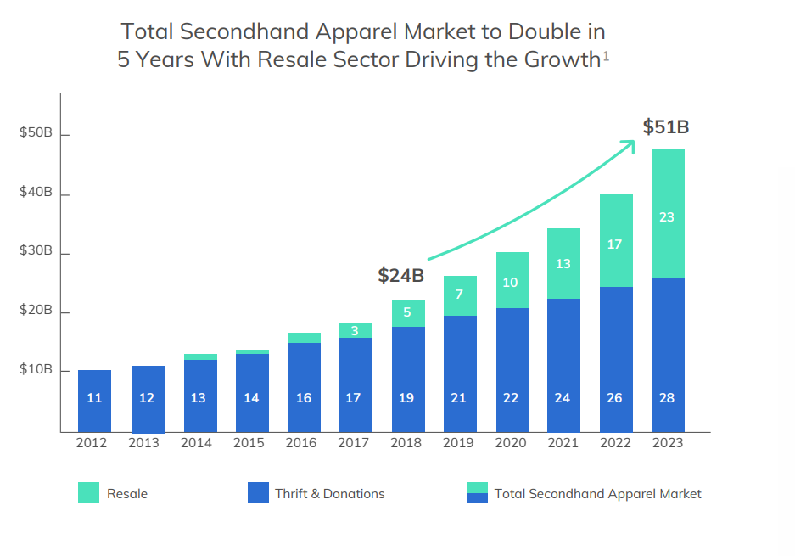Vintage resale has been growing, in the past three years, at a rate which is 21 times faster than the one manifested by apparel retail. Furthermore, if we take into account the report’s statistics about expectations and growth, clothing resale is presumed to reach a value of $51 billions in 2023

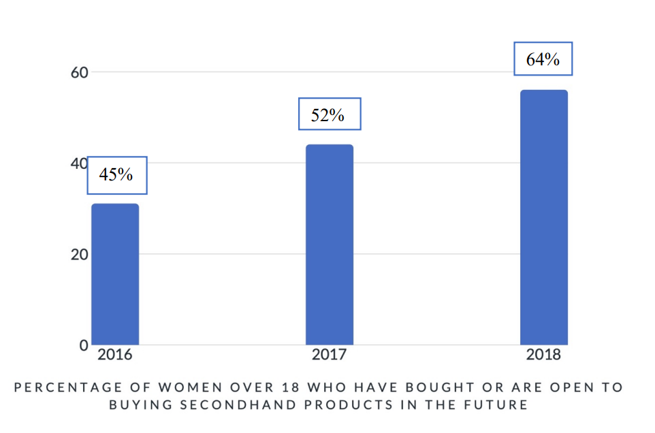This data is projected in the percentage of women who are favorable to buying second-hand clothing, going from a 45% in 2016 to a 64% in 2019. The company points out “There are more second-hand shoppers than ever” now. The numbers of women shopping vintage has gone from 44 millions in 2017 to 56 millions in 2018, once again demonstrating the sector’s growth rapidity.

The ThredUp report also provides a detailed analysis of secondhand apparel customers, with a focus on their age distribution

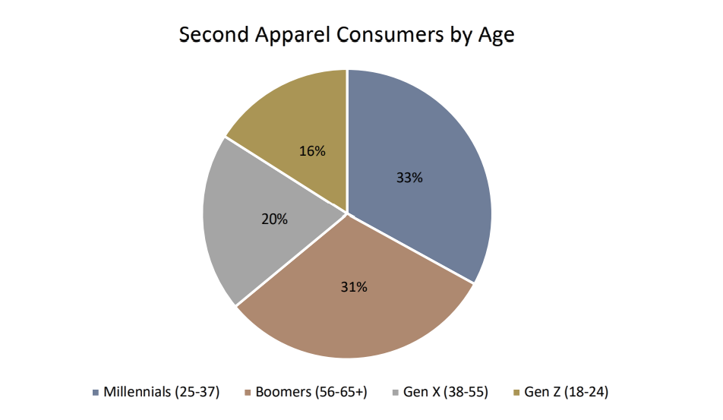

Considering the resale sector’s growth rate released by the ThredUp 2019 Report, it is unthinkable to not make a direct comparison with the fast fashion industry’s rates; in the 40 course of the last three years, the vintage apparel market has been growing 21 times faster than clothing retail. In 2008, fast fashion market had a value of $21 billions, which increased to $35 billions in 2018. The secondhand sector was accounted for a total of $9 billions in 2008 and reached $24 in 2018. By analyzing the growth rate of the last decade and projecting this data into future expectations, it is possible to estimate that, following this path, vintage wear will outshine fast fashion in 2028, leading the former in a value position of $44 billions and the latter at $64 billions (Figure 4). Such numbers provide confident and undoubtedly positive hopes for the future of the secondhand apparel market.

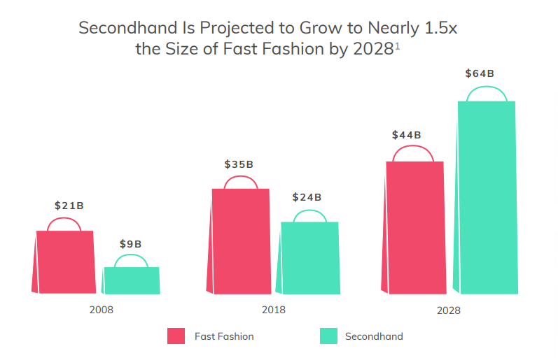

**Most popular vintage items for men and women**

|  |  |
| --- | --- |
| **Ladies vintage items** | **Men’s vintage items** |
| 1950s prom dresses | Formal wear |
| 1960s shift dresses | Evening suits |
| 1970s maxi dresses | Suits from the 1950s and 1960s Traditional dress (Kilts) |
| Evening wear – glamorous gowns, sequined | Retro Adidas tracksuit tops from the 1970s |
| embroidered dresses | 1970s Levis jeans and denim jackets |
| Real and fake fur coats and jackets | Cowboy boots |
| Cashmere jumpers and cardigans | Military dress |
| Jewellery and watches | Ties |
| Handbags, scarves and belts | Leather briefcases |
| High heels and flat boots for ladies from the 1960s, 1970s and 1980s |  |

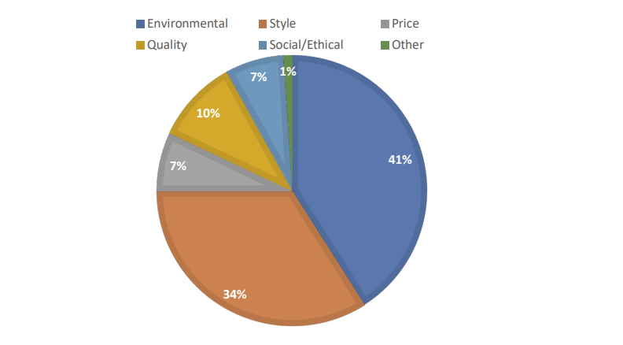**Motives Behind the choice of Vintage over Fast Fashion**

***Environmental motives:***

The graph presents the environment as the most mentioned matter behind the choice of vintage over fast fashion. This category includes the involvement of different topics, all concerned with the threatening ecological repercussions of fast fashion and positive results of vintage buying on the environment:

* Elimination of waste of natural materials and resources
* Enhancement of recycling and re-using practices
* Reduction of clothing waste
* Reduction of carbon footprint
* Reduction in overproduction and overconsumption
* Reduction in pollution

***Style:***

A surprisingly high percentage shows that a vast number of the individual surveyed sees ‘style’ as the main driver of their choice. Many respondents referred to vintage as a ‘never ending fashion’, defining its style and appearance as ‘timeless’ and mentioning how secondhand products will eventually come back in trend. Also, vintage wear is seen by many consumers as a source of inimitability: secondhand pieces are one-of-a-kind and cannot be found easily in other shops. As a consequence, vintage fashion gives individuals the possibility to be unique and inimitable in a world dominated by mass production. Many respondents highlighted how by buying vintage, “you never have to worry about someone wearing the same items as you”, allowing your personality and individuality to arise in a world were such characteristics are increasingly fading.

***Quality:***

A valuable share of the respondents reported ‘quality’ as the primary reason for their secondhand shopping choice. Many mentioned how they consider fast fashion items to be produced in a poorly manner with low-quality materials and how these products consequently present a very short-lasting life. As opposed to this, the surveyed perceived vintage clothing as manufactured in a more efficient way with the usage of higher quality materials, aimed at ensuring a long-lasting life for the garment. This aspect is strengthened by the concept of vintage itself, based on a re-usage of products; such practice could not be possible if clothes presented low-quality and short-lasting characteristics.

***Price***:

A small but still present percentage of respondents considered price as the reason behind vintage shopping. Anyhow, this factor has often been proposed as linked to the previous one of ‘quality’, meaning that secondhand clothing present a better price/quality relationship more than being generally cheaper.

***Social/Ethical motives:***

With respect to previous empirical studies of the driving motives behind vintage clothing consumption, this percentage seems to be surprisingly small, accounting for just 7% of the surveyed. The respondents mentioned the following topics:

* Overall violation of workers’ rights
* Children abuse
* Going against general modern mass production
* Encouraging local economies rather than big industries

***Other:***

This group represents the answers given by individuals surveyed which have not recurred among the other participants, leaving them to ‘isolated cases’. Nonetheless, these answers represent an important tool for the understanding of minor drivers behind secondhand clothing consumption and give voice to a share of consumers which is often undervalued. Motives included:

*Size characteristics*: today’s mass-produced items do not present a structure which is meant to fit all type of sizes, making it impossible for a certain group of consumers to buy fast fashion.

*History of an item*: already used and ‘loved’ items are considered by some, as having an added value due to their ‘hidden story’. Different respondents mentioned how, with vintage clothing, “each piece tells a story”.

*Thrifting*: some considered the pre-acquiring process of searching for a vintage item as the main driver of their choice, mentioning how going through a large amount of apparel till finding the one that captures their attention, is a practice which adds value to the purchasing process and can be compared to the one of “browsing through old music vinyl”.

**Future of resale clothing market:**

Global textiles and the clothing business are worth nearly 3000 trillion dollars (Business 2 Community, 2015). Despite this significant figure, Wright (2014) argues that in fact, the global clothing industry has failed to reach its maximum sales potential. This failure is a result of the global economic recession (Wright 2014) and political instability. (Hansen 1999) As a response to these factors, consumers’ have developed a higher appreciation of the value of reusable clothes (Rucker et al. 1995) which has subsequently provided a strong new business opportunity (Slotterback 2007).

The resale clothing markets are growing 21 times faster than the retail apparel market over the past three years globally (years 2017-2019) and resale markets are estimated to grow from seven billion to 36 billion dollars, and total second hand market size will be 64 billion dollars by 2024 (ThredUp 2020). One big reason for this estimate is the extension of the resale clothing market to online stores.

**SWOT Analysis:**

The SWOT analysis provides an overview of the strengths, weaknesses, opportunities and threats in the resale clothing market in the fashion industry. There are many ethical strengths in the resale clothing market in the fashion industry. Resale clothing companies are not under as much institutional pressure as, for example, traditional clothing companies.

On the other hand, when organizations have done little research about the second-hand clothing industry, ethical questions arise about the industry and how it operates. Also, the product ranges are very varied, which can lower consumer interest. The more ethical consumption of consumers and the impact of technology are creating many new opportunities for the resale clothing market, but they also create many upstream movements and threats in the future. Such threats include changes in the operating policies of clothing companies and the resulting challenges. The SWOT analysis is further elaborated in the opportunity section as well in threats section.

|  |  |
| --- | --- |
| **Strengths**  Affordable clothing  Green Choice  Trends  Low institutional pressures | **Weaknesses**    Scarcity of products  Low control  Unknown modes of operation |
| **Opportunities**    Changing consumer behavior  Rising awareness  Technology (Social, E-commerce)  Growing market | **Threats**  Changing Fashion Company policies  Unattractive to investment  Faster Fast Fashion  Life cycle of clothing product |

SWOT analysis of resale clothing market in the fashion industry

**Opportunities:**

The growth in popularity creates a lot of opportunities for the future of the resale clothing market. As popularity grows, new businesses emerge, and existing second-hand clothing businesses grow. Law of supply and demand theory explain that when supply increases, prices fall. Interest also grows as the more the issue is presented. Thus, more and more consumers may be interested and buy resale clothes in the future, the more they are available and their popularity increases.

The biggest focus is on promotion as well on place. New collections are being marketed and potential trends as well as an ethically positive public image correlate marketing and people’s awareness on the resale clothing. There is also a strong emphasis on the location of resale clothing stores and product logistics. Product coverage creates challenges but also opportunities for resale clothing companies. The range of products is wide, but each product is unique, and its availability may be rarer, which can often lead to impulsive purchasing decisions

An important role for the future of the resale clothing market is to highlight information about recycling and its importance for clothing products. According to the non-profit, organization Remake, 80% of all clothes are disposed globally and only 20% are recycled (2018), even up to 95% of the textiles that are land filled each year could be recycled (Secondary materials and recycling textiles 2013). Looking to the future, if recycling habits changes and clothes were recycled more, they would also be sold more used, which would reduce CO2 emissions and create more environmentally friendly supply and consumption. This would positively correlate the growing resale clothing market.

One big major opportunity in the resale clothing market is the customization and redesign of used clothing. Political instability and economic uncertainty have increased, as a result of which the demand for fashion products is declining and at the same time cheaper customized as well as personalized fashion is expected to rise in the coming years (Gazzola et al. 2020). Currently, customization and re-design is still small, and the creators are either individual entrepreneurs or drift shops, but looking in the future, the business of remade, redesigned, refashioned fashion is able to break through the world through the multitude of clothing (Meta 2020).

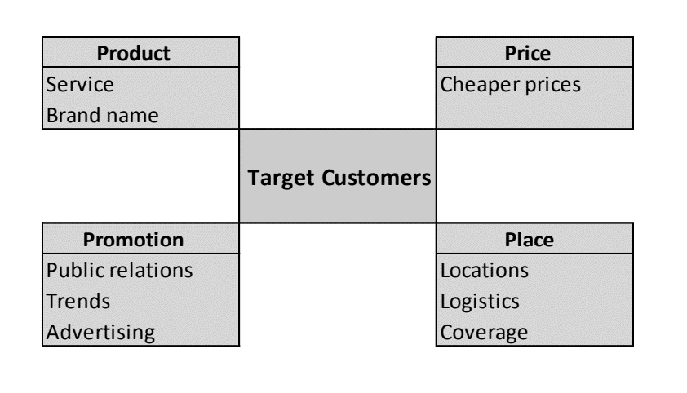

Resale clothing company analysis using a marketing mix

**Threats**

Overall, resale clothing markets have received a positive public image around the world and have been identified as part of the solution to the demand for higher consumption and the resulting waste culture. However, the resale clothing market has a significant number of threats for the future and very little public discussion, as the resale clothing market is currently a big trend and, on the rise, especially in the west countries. With the chancing company policy in fashion companies, a great confrontation is emerging in the clothing industry, neither of which will serve the rise of resale in the resale market in the future:

* **Fashion companies are changing their policies in a more ethical direction:**

Clothing companies, especially fast fashion companies, are starting to change the structure of their companies and produce more and more ethically produced clothes, therefore prices will rise in these companies, but at the same time the quality of clothes may improve. As the quality of clothing improves and prices rise, consumption is less frequent, and the product is likely to have a longer life due to a reduced impulsive purchasing decision (Gazzola et al. 2020). Thus, clothes end up less and less often at resale clothing markets and new consumption habits may also have a negative effect on consumption at resale clothing markets.

* **Heavily marketed faster fast fashion trying to compete against the first option:**

Changed consumer behaviours have also spawned counter-current business strategies such as faster fast fashion. These companies have cut their supply chain to achieve and supply more products faster in online, with bigger volume. There may be several hundred new products a week and a lot of money is put into marketing. (Marci 2019) Asos and Fashion Nova are examples of faster fast fashion companies.

Impulsive buying as well poor quality of clothing are also problem and threat for the resale clothing markets. Due to a lack of thorough consideration, impulsive buyers are likely to experience post-purchase regret (Kang and Johnson 2009). Post-purchase regret may result in the product being thrown in the trash due to its poor quality, to the return, where the company will throw it away, or the customer will throw the product in the wardrobe leaving the product unused. However, buying resale clothing can be impulsive as the selection is very haphazard and based on the supply of the moment. A Czech study found customers consider quality but look for special offers and good prices (Svatosová 2013). This led to popularity in purchasing second-hand goods and shopping online (Smith, Menon, and Sivakumar 2005; Cervellon, Carey, and Harms 2012). The low price of resale products may affect the buyer's negative postpurchase behaviour.

* **Example:**

A new kind of corporate policy emerging from Patagonia example; clothing with a lifetime warranty and repair options will reduce the growth in popularity of the resale clothing market in the future. In addition, several companies hoarded their old products to reduce their resale and utilize their materials for future collections. Many clothing companies have set up recycle bins inside their stores, where by putting your old clothes in, you get discount coupon for your future purchases (Mehta 2019). For example, H&M implants a tree through its not-for-profit partner for every 50 pounds of donated clothing. H&M is estimated to implant 100 000 trees in 2020 (H&M 2019). For customer it is an easy way to recycle your clothes, benefit from it financially and do an environmental act. At the same time, such activities motivate customers to buy more from that brand and fewer products remain for resale.

Resale clothing companies that receive their products from donations do not experience any institutional pressure to make their supply chain transparent. According to Finland's national public broadcasting company Yle, 50-70% from donated clothing in Finland ends up abroad. Most end up in Estonia and Lithuania, which is a problem because if textile waste is exported to countries that do not have proper waste management, environmental problems arise (Dahlbo 2020). Especially in Europe, a large proportion of donated clothing and shoes end up in the largest distribution centres, such as Soex, in Germany, which is the largest distribution centre in Europe. 300,000 kilos of clothing textiles arrive to Soex every day, from which they are sold to cheaper countries in Europe or exported to Africa for sale (Yle 2020). This will be a big problem now and, in the future, as very little is currently known about ethical perspective and corporate policies about companies which sell used clothing.

**How is Secondhand Apparel Market Progressing in India?**

“*Rising Demand for Special Event Clothes to Boost Sales in the Country*”

India is one of the fast-growing secondhand apparel markets and holds a significant share of 18.2% of the entire South Asia secondhand apparel market. Furthermore, FMI predicts the India secondhand apparel market growth to surge at a CAGR of 17.9% during the forecast period, owing to the rapidly growing population, increasing disposable income, and surge in the number of startups offering secondhand clothes.

Similarly, growing demand for special event apparel across the country is playing a key role in boosting sales and the trend is likely to continue during the forecast period. Demand for special event apparel is high throughout India. Indians are quite meticulous about their formal attire.

Furthermore, local celebrities are making secondhand apparel fashionable, and consumers are discovering that clearing out their closets pays off, which is fueling the demand for used apparel.

Moreover, promotional activity, the existence of multiple significant competitors, and shifting customer preferences are offering appealing opportunities for the country's secondhand apparel sector.

**Online Shopping**

**Shopping Trend in the New Century**

With the booming of e-commerce market in the 21st century, more and more consumers are changing their shopping behavior and prefer to do their usual shopping from the comfort of their homes rather than putting up with the time consuming physical store deal. According to Statista, the revenue of online apparel and accessories is $60 billion US dollars in 2015, and is projected to be $86.4 billion US dollars by 2018.

***Online shopping*** is becoming a suitable way to make all your purchases, whether you’re at home in office, or in a different country. This is especially true for developed countries, where every store has its website you can buy from. You can easily convey about the promotions like cash on delivery and special discounts on online purchases. This trend to shop online with the comfort of your own couch has recently been taken up in the Asian region as well, especially in *Pakistan* and *India*. India seems to have adopted the trend much faster as compared to Pakistan. They have multiple fashion, furniture and food websites, along with the commonly known companies, such as Amazon and Ebay.

For ***Pakistan***, however, the adoption of such trends has been more difficult. People usually don’t trust the products being displayed in front of them. As a result, we can’t expect them to buy online and be satisfied with it. However, the youth of Pakistan is open-minded and has slowly embraced online shopping, even if it’s ordering food online. People, in Pakistan, have been victims of scams both online and on mobile applications, so it’s understandable why they look suspiciously at such an activity. This recent trends have led researchers to believe that age isn’t the only factor causing the youth to turn towards online shopping. Other factors are also involved in making online shopping one of the fastest growing markets in Pakistan, which is greatly helping the IT industry in Pakistan to flourish.

**Online Purchasing Behavior and Attitude:**

Customers’ attitude toward online shopping for services depends on familiarity with the service provider and customers’ experience with the Internet. Monsuwe (2004) state that customers’ attitudes toward online shopping was not only affected by ease of use, usefulness, and enjoyment, but also by exogenous factors like customer personality, situational factors, product uniqueness, earlier online shopping experiences, and confidence in online shopping. Customers’ approach toward online shopping is strongly associated with Internet acceptance. The perceived ease of use and perceived usefulness determine customers’ attitudes toward online shopping, however, perceived usefulness did not affect user acceptance of online shopping models.

**Perception of Online Shopping:**

The consumer's perception of their experience while shopping online is also a factor to consider. When the consumer’s experience exceeds their expectations, there is a high chance they will become *loyal* towards that particular online shop. This satisfaction is based on a number of features such as: how fulfilling the experience was, how smooth the transaction was and the ease of interaction (Chen & Chang, 2003).

The shopper’s perception will also vary depending on what kind of product they are looking to purchase. Factors which may affect the perception of online shoppers are: how exposed they are to the market, market ambiguity and the position of competitors in the market (Gong et al., 2013). Comparatively, generation Y is very attached to online shopping and spends their time looking into and fantasizing about online products.

They are attentive towards sales promotions and are influenced by celebrities when it comes to fashion (Hill et al., 2013). A recent research found that almost half of the respondents were spending a minimum of one hour every day on online retail websites. It was also found then men’s fashion has led more men to participate in online shopping (Lachman & Brett, 2013). Overall, consumers are now freely accepting the concept of online shopping and this phenomenon is continuously growing.

A survey conducted by University of Punjab shows the results of demographics of the youth buying online as well as tell us which websites are popular and which products are people most willing to purchase using online shopping

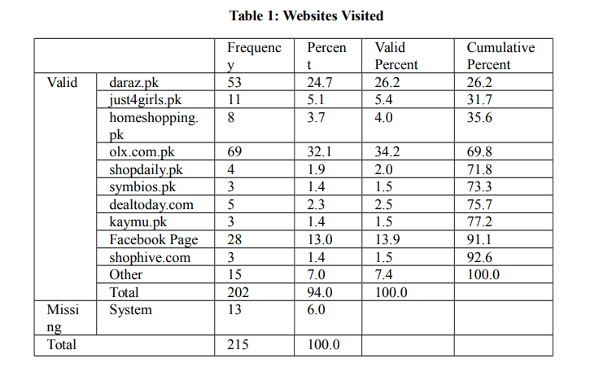

**Commonly Visited Websites**

**Products Bought**

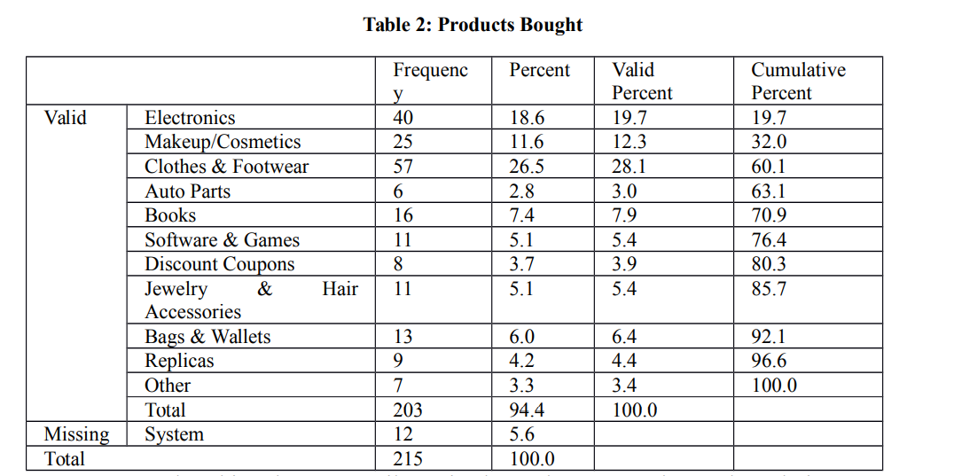

**Influence on Customers Behavior:**

Consumer buying behavior is influenced by the major three factors:

***Social Factors:*** Social factors refer to forces that other people exert and which affect consumers' purchase behavior. These social factors can include culture and subculture, roles and family, social class and reference groups.

***Psychological Factors:*** These are internal to an individual and generate forces within that influence her/his purchase behavior. The major forces include motives, perception, learning, attitude and personality.

***Personal Factors:*** These include those aspects that are unique to a person and influence purchase behavior. These factors include demographic factors, lifestyle, and situational factor.

**Impulsive buying decision:**

When purchasing items impulsive, the buyer might not have any idea about the purchase before walking into the shop. Impulsive buying is basically defined as an unplanned buying (Dittmar, Beattie, & Friese 1995). There can be many things affected to the impulsive buying decision, for example price, offer or limited quantity of goods. Based on several studies, in a fast fashion environment, an impulsive buying decision causes negative post-purchase feeling.

**Role of Fast Fashion:**

Fast fashion is a business strategy that reflects a rapid response to rising trends by improving design and product range quickly and efficiently to increase product value and demand for short-term fashion products (Choi et al. 2010; Sull and Turconi 2008). Negative post-purchase emotional response is positively related to recovery behaviour in instant store environments (Cook and Yurchisin 2017). When the purchase is not considered, buyers are likely to feel post purchase regret, and the garment is likely to be thrown to the bottom of the wardrobe or thrown away in addition for being returned.

**Synthesis of Vintage store and online shopping:**

In recent years, the synthesis of online shopping andvintage clothing has become increasingly popular. This combination is appealing to both fashion-savvy shoppers and those looking for unique items that stand out from the crowd. Online shopping provides convenience, affordability, and a wide selection of products; while vintage clothing offers timeless style with an individual flair.

**Appeal:**

* **Online shopping**

The appeal of online shopping lies in its ease-of-use combined with access to a plethora of options at competitive prices. Shopping websites offer detailed product descriptions as well as user reviews that help customers make informed decisions about their purchases without ever leaving home or office space. Additionally, many sites feature discounts on merchandise throughout the year making it even more affordable than traditional retail stores offering similar items at higher prices due to overhead costs associated with physical locations such as rent or utilities bills.

* **Vintage Clothing**

Vintage clothing adds character and charm by providing one-of-a kind pieces not found in modern collections offered by major retailers today - often times made from superior materials no longer used in contemporary apparel production processes such as natural fibers like wool or silk versus synthetic fabrics like polyester blends commonly seen today . In addition , there are sustainable benefits associated with buying preowned clothes which helps reduce waste generated by mass production factories while simultaneously preserving history through time honored garments passed down through generations .

**Combination:**

Overall, combining these two elements together creates an attractive option for consumers who want quality products delivered right to their doorstep without sacrificing personal style preferences. The merging of online services along side secondhand goods allows shoppers unprecedented access when it comes finding fashionable attire that suits any budget size while still being able to enjoy classic looks reminiscent days gone past

**Famous Online vintage clothing stores**

* Unique Vintage
* Beyond Retro
* Asos Marketplace
* What goes around comes around
* Etsy
* Swap
* Vestiaire Collective
* EBay
* Grailed
* Vintage Boho

**SECTION-II**

**Feasibility Analysis**

**Product (good or service) Analysis:**

**Appeal of the product:**

The appeal of second hand vintage clothing is undeniable. Not only does it provide an affordable way to stay fashionable and on trend, but it also offers a unique style that reflects the wearer’s individual taste and personality. Vintage clothing often has a story behind it, making each piece special in its own right. It can be seen as more than just fashion; wearing something with history gives you the chance to express yourself while connecting with the past at the same time.

The second-hand clothing market is booming, and it's no surprise why. With the rise of environmental consciousness, more people are beginning to understand the importance of reusing clothes instead of buying new ones. Not only does this reduce waste in landfills but also helps to create a sustainable fashion industry that supports ethical production practices.

The benefits associated with shopping preloved items go beyond just being environmentally friendly, it’s also financially savvy. Consumers can save money by purchasing quality goods at lower prices than if they were purchased brand new from retail stores or boutiques. This is especially helpful when looking for designer pieces that would otherwise be out of reach price wise due to their high cost tags when bought directly from retailers. Furthermore, there are often unique vintage finds available through second hand shops which cannot be found elsewhere, making them one-of-a kind treasures.

Overall, there has been an increase in demand for preloved apparel due its many advantages including sustainability aspects as well as financial savings opportunities. Both factors contribute towards a thriving secondary clothing market across multiple channels today! As long as consumers continue to prioritize ecofriendly options while shopping responsibly within their means then we will see even further growth in this sector moving forward into 2022 and beyond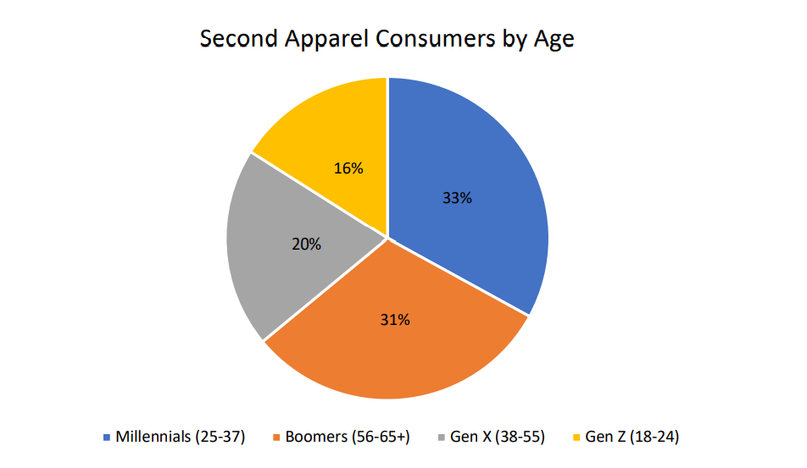.

**Grading:**

“***Grading***” in the secondhand clothing industry refers to a condition-based sorting system. At rag yards and supplier warehouses, items are sorted according to their condition and quality. “Grading” in the secondhand clothing industry refers to this sorting process. Grading systems vary by supplier, but generally, the higher the grade, the better the quality.

The following is a common grading system used by vintage wholesale suppliers:

* **Grade A** (*Grade 1*) – Clothing graded as “**A**” is in excellent condition, with few or no flaws. Some pieces may show ordinary signs of wear that could easily be addressed, such as washable stains and missing buttons. For this reason, Grade A clothing costs more than pieces graded B and below.
* **Grade B** (*Grade 2*) – This includes pieces of clothing that are in good condition. However, they may have more significant flaws and signs of heavier wear, such as broken zippers on jeans, permanent stains, rips or holes.
* **Grade C** (*Grade 3*) – This clothing is of the lowest quality. They have flaws and damage that cannot be repaired. Some suppliers will sell Grade C at a very low price to clothing resellers, but often, Grade C clothing ends up in secondhand markets around the world or shredded to make rags.

**Components**

* **Product Desirability:**

There is a growing trend for vintage products, which are seen as more authentic and unique than mass-produced items. This is especially true for items that are well-made and have a history behind them. Vintage products can be more expensive than mass-produced items, but they are often seen as worth the investment. Though there are people who are skeptical of vintage items, it is becoming increasingly likely that people will see vintage items as fashionable and beautiful. Since many vintage products have been discontinued and become rare, they are often purchased as collectibles or investments .

**Concept Statement**

**Mission Statement:**

**“**Providing customers with products that makes them feel one-of-a-kind and unique**”**

Everyone wants to be unique in their own way and not as they are part of a large group where they can’t be identified. Everyone wishes to stand out of a crowd and you can only do that if you have something different to offer

The concept for this store is simple, to provide an online platform for people to buy vintage clothing.

**Website:**

I will be building my own website for selling clothing items through either ***Squarespace*** or ***Shopify***. With these powerful platforms, I can create a beautiful and functional site that is easy to navigate, allowing customers to browse and purchase items with ease. Additionally, both Squarespace and Shopify offer robust features such as product management tools, payment processing options, customer accounts for tracking orders/purchases over time as well as analytics capabilities for monitoring the success of my store.

**Legalities:**

As a sole proprietor, I will be able to get my business up and running quickly with minimal financial investment. This is the ideal structure for a startup business such as mine because it allows me to focus on growing the business without worrying about complicated paperwork or costly legal fees associated with turning this into a corporation. With this structure, I can build my customer base and develop products or services before making any major decisions regarding corporate status.

**Sourcing Inventory:**

My plan is to import vintage clothing from wholesale vintage stores available online. First of all, it will allow me to offer a wider variety of styles and sizes to my customers. Secondly, I will be able to source high-quality pieces at a fraction of the cost of what retail stores charge. The wholesale vintage suppliers available online are:

* bulkvintagewholesale.com
* lavintage.com
* joinfleek.com
* northvintagewholesale.com
* pickvintagewholesale.com
* syedvintage.co.uk
* www.vintagekilowholesale.com

These websites allows you to purchase 25-45 kg bales of clothing items ranging from vintage hoodies, T-shirts, jackets, jumpers, coats and much more.

I cannot source my products from online or brick-and-mortar vintage stores because they have already marked up these clothing items and marking them up again would make it really hard for me earn any profit.

I would initially purchase a few of these bales, post them to my website and social media accounts, and monitor the results. If there is a market for the products, I would import a 20-feet full container and make this into a legitimate business.

If it doesn’t work out I can easily sell all that stuff on ***depop*** to get my investments back.

**Shipment Method for importing:**

These days you can use a Freight Forwarder to get a physical US address. These companies are based in the USA and will provide you with an address to use once you sign up with them. You can then use that address when placing orders on your favorite American online stores, and they will ship it internationally to you. MyUS.com is one of the best services out there. They will forward packages to any city in Pakistan, including the following cities: Sindh, Azad Kashmir, Balochistan, Khyber Pakhtunkhwa, Punjab, and Islamabad.

**Storing Products:**

My family used to have a successful business of creating and exporting tents to different countries. To facilitate this, they had set up a factory for the manufacturing process. This venture was highly profitable and allowed them to make millions over the years; however, as time passed by, demand for their product decreased significantly which ultimately led them to dissolve the company. The large factory that my family had established is still standing today and I intend on using it in order to store all clothing items once I order them in bulk.

**Product Identification:**

Vintagefashionguild.org is a website that provides a proper guidelines on how to buy and sell vintage products and how to determine which pieces are valuable and which are not. This site will be used as a reference before uploading any clothing item on the site or socials for sale.

**Pricing Products:**

I'll be pricing vintage clothing using a technique I learned on the ***Sammy d Vintage*** website. This is essentially a method for pricing vintage goods.

This formula is used in the excel file that is provided to determine an item’s pricing based on the time and money put into each piece.

**Product Photography:**

When photographing a vintage clothing item, it is important to keep in mind that the quality of the image will play a big role in whether or not potential customers will be interested in purchasing the item. A well-lit, clear photo that shows off the details of the piece is much more likely to result in a sale than a dark or blurry image. But my number one goal is to accurately representing what the clothes look like instead of editing too much and changing the colors.

**Target Market:**

The target market for an online vintage store is people who are looking for unique, one-of-a-kind items that are not available in regular stores. These customers are willing to pay a higher price for items that they feel have more value than mass-produced products. They may also be interested in supporting businesses that have sustainable and ethical practices.

To reach this target market, online vintage stores will focus on marketing their uniqueness and highlighting the story behind each item they sell. We will use social media to build a community of like-minded individuals who appreciate beautiful things with a history. By creating an emotional connection with their customers, online vintage stores can turn one-time buyers into lifelong fans.

**Target Audience**:

Our primary target consumer group consists of young adults aged 18-35 with disposable income looking for unique items at reasonable prices. This demographic typically values quality, authenticity and individualism above all else when shopping online - they want something special that no one else has. Additionally, this age group is more likely than any other demographic to be tech savvy enough navigate through an ecommerce website easily so they can quickly locate what they're looking

**Benefits of an online Vintage store:**

There are many benefits to online vintage buying application. Perhaps the most obvious benefit is that it is more convenient than going to a physical store. You can shop from anywhere at any time, which is great for busy people. In addition, you have a much wider selection of products to choose from online. And, you can often find better deals online than you would in a brick-and-mortar store.

Shopping for vintage items via an application helps reduce waste and promote sustainability practices . A lot of fast fashion ends up in landfill sites because it is made cheaply with poor quality materials . On the other hand , well-made vintage clothing can last for decades if properly cared for . So not only does shopping secondhand save you money in the long run , but it also reduces your environmental impact

**Strategy Against Competitors:**

An online vintage store will need to differentiate itself from the competition in order to be successful. There are a few ways that we plan to do this.

First, our online vintage store can focus on curating a selection of high-quality items. It can work with experienced buyers who know how to find hidden gems at estate sales and flea markets. These items will be carefully inspected for condition and authenticity before being listed on the site. This will give shoppers confidence that they are getting a great product when they purchase from the store.

Second, our online vintage store can offer personalized customer service. Shoppers would feel like they are being helped by someone who is knowledgeable and passionate about vintage finds. The staff would be able to help shoppers find what they are looking for, even if it is something specific or hard-to-find. They would also be available to answer any questions that shoppers may have about the products or the shopping process itself.

**Marketing Strategy:**

Social media pages will be created on each website so that the store can reach its target audience. The pages will be used to share information about new products, special offers, and events. The online vintage store believes that by creating social media pages, it will be able to better connect with its customers and provide them with the information they need in a timely manner.

A technique that will be used is influencer marketing i.e. partnering with models that actually care about vintage products and have a unique style so their followers can buy the same stuff as their idols.

* **Product Demand:**

The global second-hand apparel market is estimated at US$ 71,225.6 million in 2022 and is projected to expand at a prolific CAGR of 14.8% from 2022 to 2032, reaching a valuation of US$ 282,748.6 million by 2032. Growing popularity of secondhand apparel among general masses due to their less expensive nature and better quality is a key factor driving demand for secondhand apparel in the market.

**What Are The Trends Driving The Secondhand Apparel Market**?

“*Rising Penetration of Online Shopping Platforms Offering Secondhand Apparel to Bolster Market Growth*”

The digital resale is swiftly emerging as the next big trend in the fashion industry, due to increasing consumer demand and innovative digital platforms like *Tradesy* and *Postmark* that promote peer-to-peer trading of everyday clothing.

**Questionnaire**

1. What do you like least about our product?
2. Have you ever bought a vintage product?
3. Would you buy something that is expensive because its nostalgic?
4. Have you ever been to a flea market?
5. Do you find it difficult going to flea markets and endlessly search for something worthwhile?
6. Have you ever bought anything online?
7. Would you like it if you could buy vintage items online?
8. How often would you buy vintage products?
9. Are you comfortable sharing your credit card information online?
10. How much money are you willing to pay for a good vintage find?
11. Do you ever get frustrated because all the products available in market are mass produced?
12. Do you want your possessions to be one of a kind?
13. Do you believe that today the products manufactured are low quality?
14. Do you think vintage products despite being old are still long lasting?
15. Do you think buying vintage items online would save your time?
16. Would you buy vintage products just so you own something unique?
17. Do you think vintage products are better than branded stuff?
18. Do you feel good about owning vintage products?

**Industry and Target Market Analysis**

* **Target market:**

Today, vintage clothes are often seen as a fashion statement. People who wear them want to look unique and not like everyone else. As such, the target market for vintage clothing includes people who want to express their own style and stand out from the crowd. This might include teenagers, young adults, or people in their 30s and 40s.

Market segments of vintage clothing business to target:

* Teenagers and young adults who are looking for something unique to express their style
* 40 and 50-somethings who appreciate classic designs from past decades
* College students who want to stand out from their peers with something unique
* Individuals buying for a special occasion

**Teenagers/Young Adults and Vintage Clothing**

Teenagers and Young Adults are often trying to find their way and place in the world and so look to ways to express their individuality and be different. Vintage clothes are typically more unique than modern-day apparel, so teenagers and young adults see them as a way to showcase their unique style.

Additionally, vintage clothing is often more affordable than designer clothes, so it’s a cost-effective way for this group to express themselves.

Lastly, many teenagers and young adults appreciate the sustainable/ethical fashion movement and see buying vintage clothing as a way to support this cause.

**Middle-Aged Adults (40 and 50-somethings) and Vintage Clothing**

Just as teenagers and young adults are trying to find themselves, many middle-aged adults are trying to re-invent themselves. And they often turn to clothing as the easiest accessory to change.For some, wearing vintage clothing is a way to connect with their past and somehow feel younger in the process.

What is interesting about this segment of the target market for vintage clothing is that they have disposable income (unlike most teenagers and young adults). Also, this group of people will appreciate the history and story behind each piece of clothing. This means they could be willing to pay a premium for genuine vintage clothes which have been well preserved from their era.

Retailers and marketers can segment this market based on price and can consider charging extra for certain lines of clothing, knowing that their ideal customer will have the ability and willingness to pay more.

**College Students and Vintage Clothing**

College campuses are full of fashion-savvy young people, so it’s easy for vintage clothes to become popular among this group. Used clothing stores target college students because they want to capitalize on young people’s fashion trends and their dedication to eco-friendly products.

College kids who buy vintage clothes are often concerned with making a statement, so they’ll look for one-of-a-kind pieces that make them stand out from the crowd.

In addition to being stylish, college students also appreciate the value of a good deal. Vintage items can be found at thrift stores, flea markets and yard sales for a fraction of the price you’d pay at new clothing stores.

Also, modern college students can be very committed to reducing their carbon footprint. Buying used clothes is an easy way to do this because it reuses clothes that could otherwise end up in landfills.

**Vintage Clothes for Special Occasions**

A very common sale of vintage clothes happens for special occasions – like Carnival, Mardi Gras, Dress Parties and Theme Parties. For instance, if someone is invited to a 1920s or 1930s dress party, they are likely to need period clothing. In this case, they might go to a vintage clothing store and buy something appropriate for the party.

This also happens with theme parties – like an Elvis party or a Beatles theme party. For these events, people often want to dress up in clothes that reflect the planned theme and are not easily found at regular stores. So they turn to vintage shops to find something special. Using occasion-based segmentation marketers can attract customers who are looking to buy vintage clothes for special occasions.

**Market segmentation**

**Local:** In actual setting there is not local market as we are operating business through online market. No brick and mortar will be set up in the initially

**Competition**: There are existing competitors in the market, as Vintage clothing is not a new trend in the market but on the basis, of research our company over rules the other brands as no other brand provides the special customer service that would help the customers in selecting the right clothing piece so they find what they are looking for. In addition to that, we are focusing on specific market in.

**Market Size:**

|  |  |  |  |
| --- | --- | --- | --- |
| Company Name | Basic Products | The place of the project | Market Size |
| V for Vintage | Vintage clothing for men and women | Pakistan | Pakistan (delivery across Pakistan only) |

* **Trend Analysis**

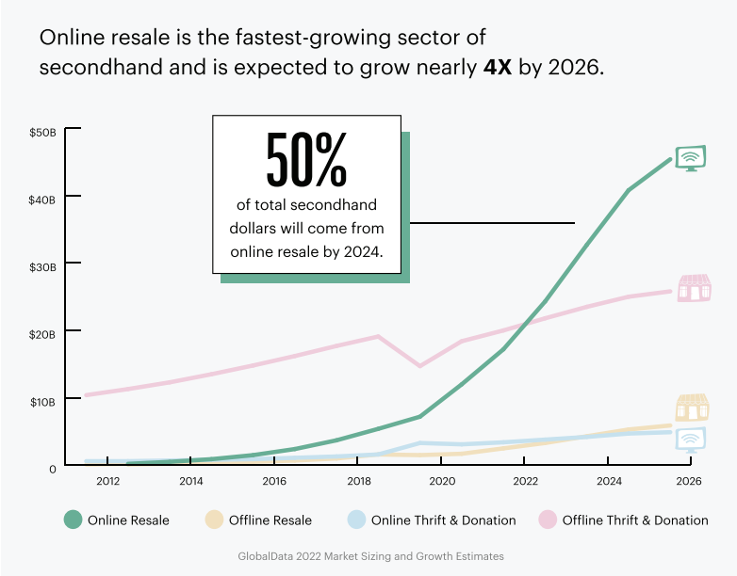

* **Purchasing Power:**

|  |  |  |
| --- | --- | --- |
| Consumer | Purchasing Power | Selectiveness |
| Male | High | Quality |
| Female | high | Quality + Price |

* **Promotion** (Product involvement):

Product involvement of the customers will be raised by raising awareness among people, about the benefits of moving towards sustainability.

***Google display ads*** to appear on relevant pages, clothing blogs to increase the involvement of people.

***Partnerships*** with bloggers, influencers, known personalities will socialize our products and brand.

***Social media*** is the biggest platform available for any brand to advertise, therefore we will tie up with major influencers and fashion bloggers to test our products and showcase their quality.

* **Competitors:**

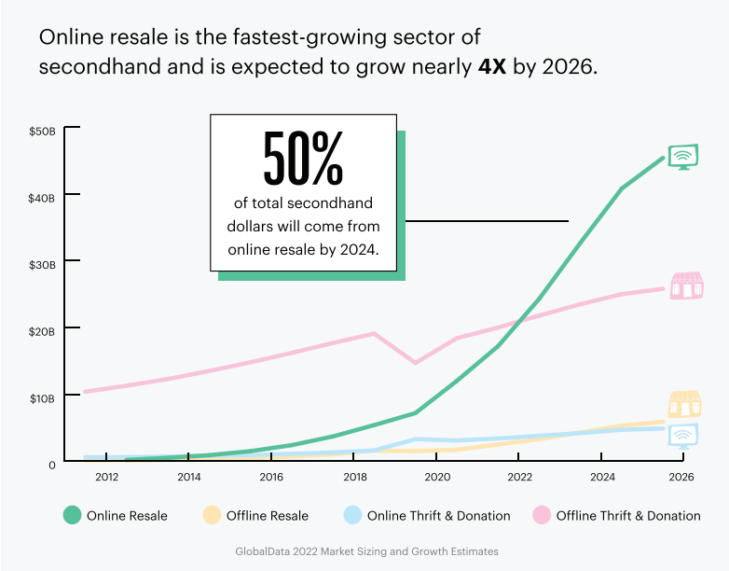The online vintage store in Pakistan is facing stiff competition from a variety of sources. In order to stay competitive and remain profitable, it must be aware of the various competitors and their offerings. This essay will discuss three types of competitors that the online vintage store in Pakistan faces: other e-commerce stores, brick-and-mortar stores, and international vendors.

First, there are many other e-commerce stores offering similar products as the online vintage store in Pakistan. These companies have access to a wide range of goods at competitive prices due to their ability to source items from around the world quickly and easily via digital platforms like Amazon or eBay. Additionally, they often offer free shipping or discounts on bulk orders which can make them attractive options for customers looking for good deals on rare finds or popular items alike.

Second are brick-and mortar shops selling similar products as those offered by an online vintage shop in Pakistan but with more limited selection due to physical space constraints such as size limitations within malls or shopping centers where these shops may be located . Customers may also benefit from one on one customer service experiences when visiting these traditional retail outlets since staff members can provide advice about specific pieces that might not otherwise be available through an automated web interface like those found at most websites today .

Lastly , there are international vendors who sell directly into markets outside their own countries including Pakistani shoppers interested specifically seeking out unique pieces made abroad . These businesses typically have larger inventories than local retailers because they draw upon supply chains established over decades if not centuries making them formidable opponents against whom even well established domestic operations must compete with regularly . Furthermore , some foreign sellers offer additional benefits such as lower prices thanks largely due tax exemptions granted by certain governments allowing them greater flexibility when pricing goods compared against domestic merchants who do not enjoy this same privilege ..

**Key Online Competitors:**

* vintagelooms.com
* Ybmbshop.com
* shoppingbag.pk
* thriftbros.pk
* secretstash.pk
* vintage.thrift.pk
* **Suppliers:**

Importing vintage clothing from wholesale vintage stores available online. First of all, it will allow me to offer a wider variety of styles and sizes to my customers. Secondly, I will be able to source high-quality pieces at a fraction of the cost of what retail stores charge. The wholesale vintage suppliers available online are:

* bulkvintagewholesale.com
* lavintage.com
* joinfleek.com
* northvintagewholesale.com
* pickvintagewholesale.com
* syedvintage.co.uk
* www.vintagekilowholesale.com
* **Products and Prices**

V for Vintage will provide variety of clothing items such as from vintage hoodies, T-shirts, jackets, jumpers, coats etc. The brand solely focuses on clothing for fashion in effort of eliminating and reducing fast fashion.

The prices of the T-shirts and hoodies products are from $10-$15, where jackets, jumpers, coats are in the range of $15-$25 the prices are in co-ordination with the services am providing. The prices have been set up after a thorough research of people behavior towards buying.

|  |  |  |
| --- | --- | --- |
| V for Vintage Products | Prices | Overall competitors prices |
| T-shirts , Hoodies | $10- $15 | $8-$20 |
| Jackets, Jumpers, Coats | $15- $25 | $15-$30 |

**Organizational Feasibility**

The purpose of the study is to show that the company has viable organization structure. The management team is logistically set and will be maintain work balance.

**Company ownership**

Hafsah Zulqarnain the founder and CEO of the company will own “V for Vintage”. In the future in case there is angel investor investing in my business I am willing to give 8 percent of the company’s share to the investor also a special position to the investor in coming future when the business will be at its hike. the founder of the company will be returning the amount taken by investor in the period of one year.

**Hierarchy**

* **Flow Chart of management Hierarchy**

**Management Prowess:**

Since it will initially only be a small-scale home business, I will first be managing every part of the company by myself. I'll wait to hire anyone until I know how the business is doing.

Our management team will be highly qualified and experienced, and the team is required to work covertly in order to produce the greatest profit for the organization. Once the company is operating and an investor has decided to invest in it, this team will be formed.

|  |  |
| --- | --- |
| Job Profiles | Number Of Employees |
| Managing Director | 1 |
| Executive Director | 1 |
| General Manager | 1 |
| Sales Manager | 1 |
| Marketing Coordinator | 1 |
| Software-expert | 1 |

* Our managing director will have a Degree in business, marketing, or a related field. He/she will have (5-6) years’ experience as a managing director or in a similar role and have experience in developing and implementing strategic and business plans.
* Our Executive Director will have a minimum of a master’s degree in business administration or a related field. He/she will have extensive experience in a similar position or senior leadership role.
* One sales manager with minimum work experience of 5-6 years will handle the sales department of the company, sales manager will have to keep monthly update of the sales report. Sales manager will manage all the sales expenditure.
* The marketing manager with minimum work experience of 5-6 years will keep an updated information about the new trend in the market; will help us in carrying out campaigns, fashion-shows also socialize our products in any possible way.

**Resource Sufficiency:**

The focus in this section is on nonfinancial resources. Use the following table to rate your “resource sufficiency” in each category. The list of resources is not meant to be exhaustive. An explanation of the rating system used in the first portion of the table is as follows:

① Available

② Likely to be available: will probably be available and will be within my budget

③ Unlikely to be available: will probably be hard to find or gain access to, and may exceed my budget

④ Unavailable

⑤ NA: not applicable for my business

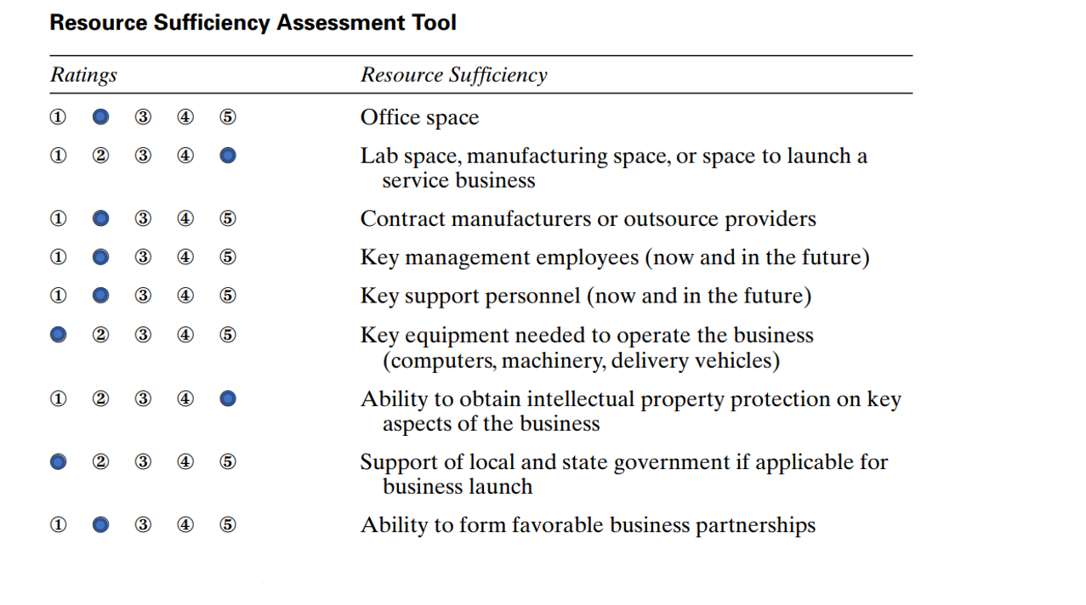

**Code of ethics:**

We need a code of ethics since we will adhere to it in order to preserve a good organizational feasibility.

**1. The work environment**

Employees should act with integrity, comply with laws, maintain a professional work environment and comply with company policies. They should treat customers, colleagues, and partners ethically at all times.

**2. Protecting company assets**

Employees should always act to protect company assets, including physical, intellectual, and electronic or digital properties.

**3. Anti-bribery and corruption**

A company's integrity is essential for maintaining trustworthiness and reputation. Employees should always do their work fairly, honestly, and legally.

**4. Absence without notice**

Employees who are unable to work due to illness or an accident should notify their supervisor. This allows the company to arrange for coverage of their duties and helps others continue to work in their absence. If an employee does a report for work and the company is not notified of an employee's status for 3 days, it is typically considered a job abandonment.

**5. General harassment and sexual harassment**

This company is committed to providing a work environment free of discrimination and unlawful harassment. Actions, words, jokes, or comments based on an individual’s sex, race, ethnicity, age, religion, or any other legally protected characteristic are not tolerated.

**6. Dress code**

A professional appearance is important when employees work with customers or potential customers. Employees should be well-groomed and dressed appropriately for the business and for their position.

**7. Substance abuse**

The manufacture, distribution, possession, sale, or purchase of controlled substances of abuse on company property is prohibited. Being under the influence of illegal drugs, alcohol, or substances of abuse on company property is prohibited. Working while under the influence of prescription drugs that impair performance is prohibited.

**8. Internet use at work**

Employees may use the Internet when appropriate to access information needed to conduct company business. Use of the Internet must not disrupt or injure the company computer network. Use of the Internet must not interfere with an employee's productivity.

**Financial Feasibility**

The purpose of the study is to show that the proposed project is financially feasible and will make a projection on the rate of return on invested capital. Viability of the proposed venture by evaluating the start-up costs, operating expenses, cash flow and making a forecast of future performance.

* **Startup Cash:**

1. The minimum startup costs for a vintage clothing business: **$1,817**
2. The maximum startup costs for a vintage clothing business**: $27,209**
3. The average startup costs for a vintage clothing business: **$13,936**

**Software Expenses:**

For our online vintage store specifically, the right software will be invaluable in helping us in managing our inventory effectively and efficiently while providing customers with accurate information on what’s available for sale at any given time. Software also allows for easy integration with other services such as shipping companies or payment processors which simplifies the entire transaction process for both parties involved – saving precious time in the long run. Furthermore, specialized tools like analytics programs can give owners insight into how their products are performing against competitors so they know where improvements need to be made in order to stay competitive within the industry landscape.

In conclusion, having access to quality software is absolutely essential when opening an online vintage store – not only does it make operations more efficient but will also provide invaluable data-driven insights that will help us drive decision-making processes throughout all stages of growth. With its many advantages over traditional methods of doing business, investing in reliable technology solutions is definitely our top priority

**List of Software Expenses:**

|  |  |  |  |
| --- | --- | --- | --- |
| Cost | Required | Min Cost | Max Cost |
| File Hosting Service | Recommended | $0 | $299 |
| Email marketing tool | Recommended | $0 | $100 |
| Accounting & Invoicing Software | Recommended | $0 | $50 |
| Project Management Software | Recommended | $0 | $25 |
| Internal Communication Tool | Recommended | $0 | $20 |
| Design Programs & Software | Optional | $0 | $50 |
| IT Support | Optional | $150 | $2,000 |
| Social Media Management Tools | Optional | $0 | $50 |
| Payroll Software | Optional | $0 | $200 |

**Office Space Expenses:**

At first, no office space will be required as this is just a start up and will be operated online. However, if the business grows it might become essential to set up an office space.

**List of** **Office Space Expenses:**

|  |  |  |  |
| --- | --- | --- | --- |
| Cost | Required | Min Cost | Max Cost |
| Rent | Optional | $0 | $5,750 |
| Utility Costs For Office Space | Optional | $0 | $1,150 |
| Wi-Fi & Internet | Optional | $0 | $100 |

**Inventory Expenses:**

Inventory expenses are an important part of opening any type of store, and this is especially true for online vintage stores. To ensure success in the industry, it is essential to have a well-stocked inventory that meets customer needs. This means carefully considering what products should be stocked and how much money will need to be invested in order to acquire them.

When budgeting for inventory expenses, we have considered both the upfront costs associated with purchasing items as well as ongoing costs associated with restocking or replacing items when necessary. Additionally, we have taken into account any fees that may apply such as shipping charges or taxes which could affect your overall budget significantly if not accounted for properly ahead of time.

Overall, having a clear understanding on inventory expenses before launching an online vintage store is key towards achieving success within the industry due its competitive nature.

**List of Inventory Expenses:**

|  |  |  |  |
| --- | --- | --- | --- |
| Cost | Required | Min Cost | Max Cost |
| Upfront Costs For Inventory | Optional | $300 | $5,000 |
| Inventory Storage | Optional | $0 | $5,000 |
| Package Design | Optional | $50 | $3,000 |
| Shrinkage | Optional | $0 | $1,000 |
| Distribution costs | Optional | $0 | $750 |

**Website Expenses:**

Website expenses are one of the main costs associated with opening an online vintage store. Depending on how much control you want over your website, these costs can vary greatly from hosting fees for basic design templates or custom coding that allows you full control over every aspect of your site’s design and functionality. Additionally, there will likely be some cost involved in setting up payment processing systems so customers can purchase items securely from your website as well as any other necessary add-ons such as shopping cart software or customer management tools depending on what type of products you offer for sale through your site.

Finally, there is also ongoing maintenance fees related to keeping everything running smoothly once it's all set up; this could include regular backups and security updates along with monitoring services that help keep track of traffic flow and performance metrics which will give insight into how visitors interact with different areas throughout the site allowing more informed decisions when making changes or additions down the road if needed.

**List of Website Expenses:**

|  |  |  |  |
| --- | --- | --- | --- |
| Cost | Required | Min Cost | Max Cost |
| Domain Name | Required | $12 | $200 |
| Business Email Hosting Service | Recommended | $1 | $15 |

**Advertising and Marketing costs:**

As an online vintage store, advertising and marketing will be essential to the success of my business. Advertising is key in helping potential customers learn about my products and services. It can be done through a variety of channels such as radio, television, print media or digital platforms like social media. This will help me reach out to more people who may not have heard about my business before and create awareness for it among them.

Marketing on the other hand will help me build relationships with existing customers while also acquiring new ones by creating customer loyalty programs or offering discounts on certain products from time to time that appeal to their interests . Additionally I could use email campaigns which would enable me target specific audiences based on their past purchases or preferences thus ensuring that they receive content specifically tailored for them increasing chances of conversion into sales.

**List of Advertising and Marketing Expenses:**

|  |  |  |  |
| --- | --- | --- | --- |
| Cost | Required | Min Cost | Max Cost |
| Customer Research & Surveys | Optional | $0 | $300 |
| Affiliate Marketing Commission & Fees | Optional | $0 | $250 |
| Influencer Marketing | Optional | $0 | $750 |
| Press | Optional | $0 | $500 |
| Google Ads | Optional | $0 | $300 |
| Facebook & Instagram Ads | Optional | $0 | $350 |

**Planned Investment:**

|  |  |
| --- | --- |
| Self –investment | $1817 |
| Investor investment | $13936 |
| Total Investment | $15753 |

I will choose the minimum costs for a startup, which is $1817. This investment will come from myself. My father will be the investor in this scenario. As I do not have to pay this money back right away, I may easily put up this firm on a minimal level and see where it goes. If the company fails, I will sell everything on Depop or sell it to local vendors to recoup my investments and repay my father. However, if this venture is successful, I will wait until I have enough money to reimburse my father. If I take loan ($13936) from the bank, I will pay it back in installments from the profit earned from this business. However, if I find an angel investor, investor will own 8 percent of company share until I pay it back.

**Overall Financial Attractiveness:**

* **Financial Projections**

Ongoing expenses will include utilities, employee salary, taxes, advertising, and insurance. Maintaining a consistent flowing inventory will be a significant cost to keep the store running effectively. Another consistent cost will include advertising expenses that cover paid ads, website maintenance, and affiliate/influencer contracts.

### **Revenue:**

* 2023: $17,000
* 2024: $26,000
* 2025: $45,000

### **Expenses/Costs:**

* 2023: $14,000
* 2024: $18,000
* 2025: $30,000

### **Profit:**

* 2023: $3,000
* 2024: $8,000
* 2025: $15,000

**Pros of Vintage Clothing Business**

|  |  |
| --- | --- |
| Pros | Description |
| Flexibility | You can put as much time into the business as you'd like. If you like the work and have some initial experience, you can start small and manage all aspects of the business on your own. |
| Ability to start your business from home | It's not necessary to have a physical storefront or office space to get your business started. You can do everything from the comfort of your own home, at least in the beginning! |
| Little startup costs required | The cost to start a vintage clothing business costs significantly less money than most businesses, ranging anywhere from 1,817 to 27,209. |
| Rewarding work | Starting a vintage clothing business can be really rewarding work. After all, you are solving an immediate issue for your customer and you're working on something you truly care about. |
| Scalable | With businesses and processes changing daily, there will always be demand for new features, products and services for your business. Additionally, there are several different business models and pricing tiers you can implement that will allow you to reach all types of customers. |
| High margins | The gross margins for your vintage clothing business are typically around 40%, which is considerably high and allows you to grow your business and manage costs easily. |
| Quick build time | The average time it takes to build your product is quick - typically around 7 months. This will allow you to bring your product to market faster. |
| Easy to encourage | In the vintage clothing business, you have a much higher chance of encouraging your customers to buy - you can easily alter the price, placement, packaging, and promotional value to influence the decision of your buyer. |
| Unlimited income potential | With starting a vintage clothing business there is no cap as to how much income you can make. The stronger your business skills and the more energy/time you put into your career, the more you'll make. |
| Amazing perks and discounts | Working in the vintage clothing business comes with its perks! As a seller for these products/services, you typically also get to enjoy industry perks and discounts. |
| You are your own boss! | With starting a vintage clothing business, you are the one to make decisions for almost all of the operations. Calling the shots can be empowering and liberating! |
| Higher likelihood of getting referrals | This business is all about referrals, which can be a a very impactful way to attract and retain customers. It's critical that you have a great referral program in place that incentivizes your customers to tell their friends about your product. |
| Simple business model | A vintage clothing business has the advantage of a simple business model, which makes launching and building the business more seamless. |
| Control your own destiny | Starting A Vintage Clothing Business allows you to control every aspect of your life and make your own dreams come true every day. |
| You get to do something you truly love | With starting a vintage clothing business, you get to put your energy into something you are truly passionate about! You'll find yourself devoting as much time and energy as possible into the business to make it successful. |
| Ecommerce retail is growing fast | Ecommerce has been grown rapidly over the years and is expected to hit a total of 4.9 trillion dollars by 2021. With running an ecommerce business, you provide your customers with alternative and more convenient shopping experience, which will ultimately drive sales. |
| Various different ways to make money | With starting a vintage clothing business, there is not just one business model to choose from. This field is amazing in that there are various different ways to make money. Although this may complicate things, it's great to have different options and sources of revenue. |
| Make money while you sleep | The advantage of starting a vintage clothing business is that you have the ability to have passive income and make money while you sleep. This is the dream for many entrepreneurs. |

**Cons of Vintage Clothing Business**

|  |  |
| --- | --- |
| Cons | Description |
| Crowded Space | Competition is high when it comes to your vintage clothing business, so it's important that you spend a good amount of time analyzing the market and understanding where the demand lies. |
| Finding The Right Supplier | Most businesses in this space go the supplier/manufacturer route, which isn't a bad thing. However, finding the right supplier can take a lot of time, energy and trial/error. If done properly, this process can save you months (if not years) of time and energy. |
| Security Issues | With any Saas business, data loss and security issues may arise throughout your process of building your product. It's critical that you understand exactly what you're responsible for and how to avoid potential issues down the road. |
| Lack of benefits | With a vintage clothing business, you are typically self-employed and responsible for finding your own insurance, which can be quite costly and time-consuming. |
| Isolation | Often times, as a vintage clothing business, you typically work alone and do not have much face-to-face interaction with other team members. |
| Taxes | As a vintage clothing business, you typically pay self-employment taxes which can be quite high. It's important to understand what you will be paying in taxes each year so you can determine if the work you're taking on is worth it. |
| No safety net | Typically, as a vintage clothing business, you do not receive a consistent pay-check and instead earn money based on your transactions each month. During the slow periods, you typically take away less since the job is based on commission. It's important to budget accordingly for the slow times. |
| High overhead expenses | With starting a vintage clothing business, there are overhead expenses that come with selling a physical product. You will want to make sure you strategically budget for these overhead costs. We discuss this more in the startup costs section below. |
| You may need to charge sales tax | If you are selling your products in various states, you may be required to charge sales tax. Although this may not impact your financials specifically, it can be a headache to create a process and procedure for this. |
| Difficult to build trust with your customer | With starting a vintage clothing business, there can be minimal face-to-face interaction, which means it can be a lot more difficult to establish trust with your customers. You'll need to go the extra mile with your customer to grab their attention and business. |
| Minimal physical activity | A big part of starting a vintage clothing business is sitting at a desk for the majority of the day starting at your computer. Some may enjoy this, but others may struggle with sitting for the majority of your day without much physical activity. |
| Learning Curve | When you start your own business, you no longer have upper management to provide you with a playbook for your roles and responsibilities. You should know the ins and outs of every aspect of your business, as every decision will come down to you. |

**Conclusion**

The feasibility study of an online vintage clothing store has been completed. After a thorough analysis, the results show that such a venture will be both profitable and feasible. The research conducted throughout this report has revealed that there is consumer demand for vintage apparel, as well as numerous opportunities to capitalize on existing market trends with an online business model. Additionally, due to the relatively low start-up costs associated with launching such a business and the potential for fairly high returns on investment should it prove successful, this project appears to be highly viable in terms of cost/benefit ratios.

Overall, while certain risks are inherent in any new venture—particularly one related to e-commerce—the data collected during this study suggests that launching an online vintage clothing store would likely yield positive financial returns over time if managed properly from inception through growth stages. With careful planning and strategic marketing techniques aimed at targeting niche markets within the industry’s current customer base (such as millennials, GenZ), success can potentially be achieved even faster than initially anticipated when conducting initial research into profitability projections prior to launch day .

# **References**

**Report, articles and journals**

* Fischer, N. L. (2015). Vintage, the First 40 Years: The Emergence and . *Cultural Unbound*, 22.
* Sharma, Vriti. (2021). Feasibility Study for a sustainability based clothing Start-up.
* Vanicore , L. (2020). “Vintage Fashion: An Example of Circular Economy as a sustainable alternative to the Fast Fashion.
* Arsalan S. Khan, Faisal Ahmed, Hassan Yousuf, Sohaib ul Hassan and Syed Abbas Zia (2014).”Online Shopping Behavior in Pakistan”
* Jasper , K. (2022). Business Plan: Vintage Clothing Resale. Hame University of Applied Sciences.
* Nazir, Sajjad & Tayyab, Arsalan & Sajid, Aziz & Rashid, Haroon & Javed, Irum. (2012). "How Online Shopping Is Affecting Consumers Buying Behavior in Pakistan?”. International Journal of Computer Science Issues. 9.
* Cassidy, Tracy & Bennett, Hannah. (2012). The Rise of Vintage Fashion and the Vintage Consumer. Journal of Fashion Practice. 4.
* Tulsi , R. Study of Effectiveness of Online Shopping.
* Fasih, S. T. (2020). Professional Women Behavior Pertaining to Online Shopping in Pakistan.
* Appelgren & Bohlin, S. A. (2015). Introduction: Circulating Stuff through Second-hand, Vintage and Retro Markets. Cultural Unbound.
* MITTAPELLI, C. R. (2005). ONLINE SHOPPING. Osmania University.
* (2022). Thread Up Annual Resale report.
* Javed, A., & Khan, S. (2014). Consumer Perceptions of Brand Trust Online of Clothing in Karachi: A Case Study of Gul Ahmed. Geist Science.
* Busso, C. (2021). The Principle of Rarity on Vintage Clothing: Consumers’ preferences and self-expression.
* Chaudary, S., & Nisar, S. (2014). Factors Influencing the Acceptance of Online Shopping in Pakistan.
* Valor , C., Ronda b , L., & Abril c, C. (2021). Sustainable Production and Consumption. Elsevier.
* Hokkanen, O. (2018). Opportunities and Threats in the Future Resale Clothing Market. Metropolia University of Applied Sciences.

**Websites:**

* Taylor , M. (2016, November 30). How to start an online vintage store. Racked. <https://www.racked.com/2016/11/30/13769482/how-to-start-an-online-vintage-store>
* Major, J. S. and Steele, . Valerie (2022, October 26). fashion industry. Encyclopedia Britannica.

<https://www.britannica.com/art/fashion-industry>

* Vintage-clothing. Entrepreneur.com.

<https://www.entrepreneur.com/businessideas/vintage-clothing>

* Crosby, J., & Lipscomb, A. (2021, November 17). Old is new again: How vintage fashion is now a multi-billion dollar industry. Carolinanewsandreporter. <https://carolinanewsandreporter.cic.sc.edu/old-is-new-again-how-vintage-fashion-is-now-a-multi-billion-dollar-industry/>
* SANTIAGO, F. S. (2022, January 12). For Some Millennials, The Y2K Comeback Is A Second Chance At The Era’s Biggest Fashion Trends. Refinery29.

<https://www.refinery29.com/en-us/2022/01/10827628/y2k-fashion-trend-millennials>

* GRECHKO, I. (2020, July 21). Resale Is Thriving In The Pandemic. Refinery29. <https://www.refinery29.com/en-us/2022/01/10827628/y2k-fashion-trend-millennials>
* GRECHKO, I. (2021, April 2). Here is What It Takes For Fashion Brands To Be Sustainable. Can The Industry Be Saved? Refinery29.

<https://www.refinery29.com/en-us/can-fashion-be-sustainable>

* RASHED, K. (2020, November 15). How Vintage Menswear Went From ‘Secondhand’ to Hot Commodity. Robbreport.

<https://robbreport.com/style/fashion/vintage-menswear-market-booming-1234576242/>

* <https://www.oberlo.com/statistics/apparel-industry-statistics>
* <https://earth.org/fast-fashion-statistics/>
* <https://www.cudoni.com/blog/difference-between-vintage-and-second-hand/#:~:text=By%20definition%2C%20second%2Dhand%20clothing,people%20have%20owned%20it%20beforehand>
* <https://www.starterstory.com/ideas/vintage-clothing-business/startup-costs>
* <https://www.bplans.com/vintage-store-business-plan/>
* [How to sell clothes on Depop: Everything you need to know to start selling - Depop Blog](https://blog.depop.com/articles/how-to-sell-clothes-on-depop-everything-you-need-t)
* <https://www.globaldata.com/store/?s=sustainable%20fashion&wpsolr_sort=publication_date_st_desc>